**Information System Management Lab**

**BCOM 307**

**Assignment #12**

***Submitted by:***

**Name:** YASH JAIN

**Enrollment No:** 03914788818

**Semester:** B.Com(H) 5th Semester

**Class:** B.COM(H)

**Section:** B.Com 5A

**Date of Submission:** 04/10/2021

***Submitted to:***

**Praveen Kumar Singh**

**Assistant Professor, MAIMS**



**Department of Commerce**

**Maharaja Agrasen Institute of Management Studies**

**Affiliated to Guru Gobind Singh Indraprastha University, Delhi**

**Sector -22, Rohini, Delhi -110086, India; www.maims.ac.in**

Maharaja Agrasen Institute of Management Studies

Affiliated to GGS IP University; Recognized u/s 2(f) of UGC Recognized by Bar Council ofIndia; ISO 9001: 2015

Certified Institution Sector 22, Rohini, Delhi -110086, India; [www.maims.ac.in](http://www.maims.ac.in/)

Department of Commerce

Academic Year: 2020-21

Semester: Vth

# Assignment No.12

# Unit No:

**Course/Subject Code:** BCOM 307 **Subject Title: Information System Management Lab**

# Issue Date: Last Date of Submission:

**Instructions for Students:**

# All Questions are Compulsory.

1. The student should attach proper cover page for each assignment clearly mentioning the Assignment No.
2. Each assignment should be prepared by the student individually with proper explaination and screenshots.
3. A4 size ruled sheets should be used for the assignment.
4. Assignment pages should be serially numbered at the bottom of page.

***During online education mode, upload scanned copy of the complete assignment including cover page latest by due date.***

|  |  |  |
| --- | --- | --- |
| **Question No.** | **Question** | **CO No.** |
| 1 | Drop column pincode from the table clients. | **CO2, CO3, CO4** |
| 2 | Change the column ‘Address' size to 40. |
| 3 | Update the following for client 107 -  1. Name - SMITH  2. Baldue - 5000 |
| 4 | Change the name of table clients to client_master. |
| 5 | Delete from client_master where the column state holds the value 'Uttar Pradesh'. |
| 6 | Add a column called 'City' of datatype char and size 15 to the client_master table. |

**ASSIGNMENT 12 - PRACTICE FOR ALTER COMMAND**

**Task 1 : Drop column pincode from the table clients.**

This task can be completed using the **‘alter’** command, with the **‘drop’** keyword.

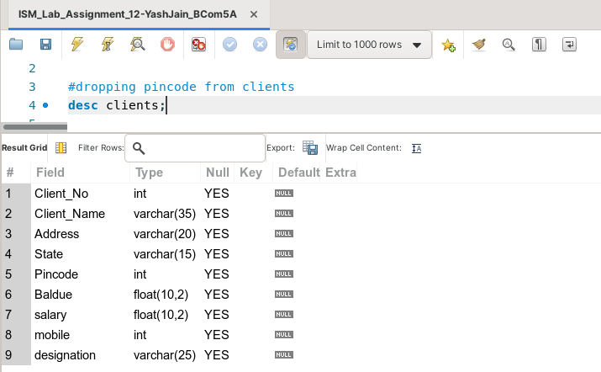

(before dropping pincode column)

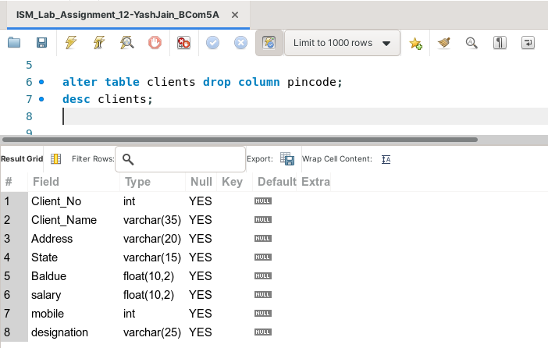

(after dropping pincode column)

**Task 2: Change the column ‘Address' size to 40.**

This task can be completed using the **‘Alter’** command, with the **‘modify’** keyword.

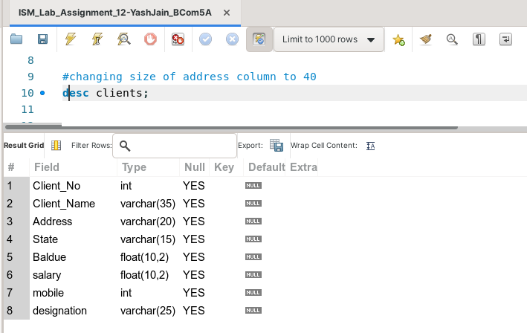

(before modifying the size of ‘address’ column)

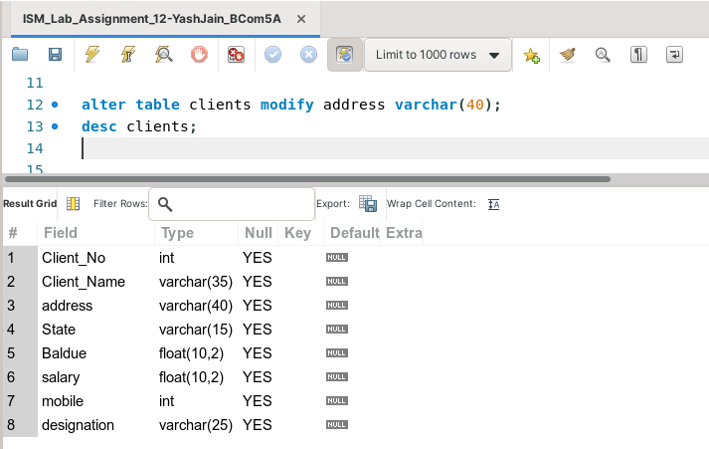

(after modifying size of ‘address’ column)

**Task 3: Update the following for client 107 -**

**1. Name - SMITH**

**2. Baldue - 5000**

This task can be completed using the **‘update’** command along with the **‘set’** keyword, with the **‘where’** clause.

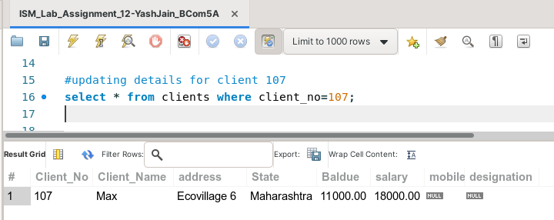

(before updating the record)

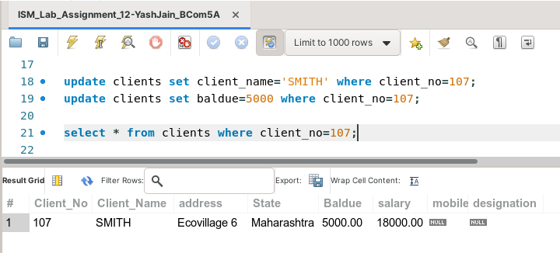

(after updating the record)

**Task 4: Change the name of table clients to client_master.**

The following task is completed using the **‘rename table’** command, with the **‘TO’** keyword.

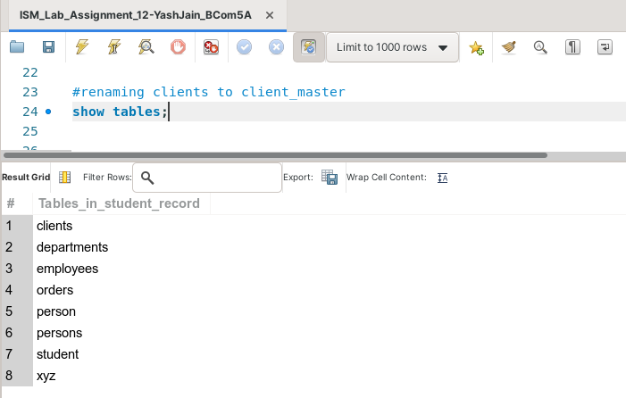

(before renaming table)

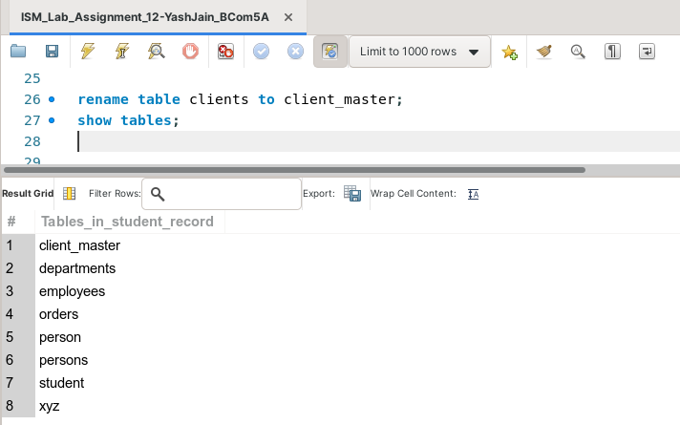

(after renaming table)

**Task 5: Delete from client_master where the column state holds the value 'Uttar Pradesh'.**

This task can be completed using the **‘delete from’** command, along with the **‘where’** clause.

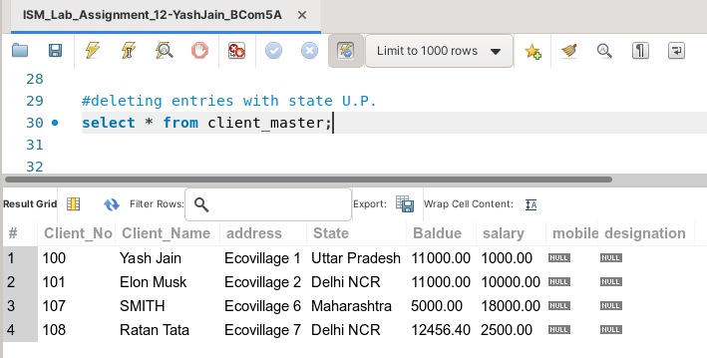

(before deletion)

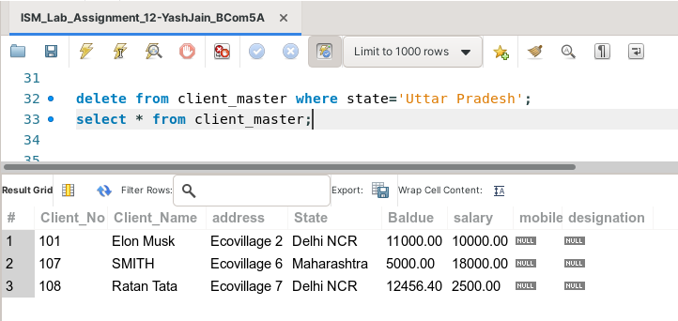

(after deletion)

**Task 6: Add a column called 'City' of datatype char and size 15 to the client_master table.**

This task can be completed using the **‘alter table’** command, along with the **‘add’** keyword.

